EXP.NO: 1
Web Page Creation using HTML

AIM:
To create a web page that embeds a map with hotspots, frames, and links. The web page should be designed using HTML, incorporating embedded, external, and inline CSS for styling. This exercise aims to enhance understanding of integrating multimedia elements like maps, creating interactive hotspots, and organizing content using frames while applying different CSS techniques for styling.

ALGORITHM:
1)Create the HTML Structure:
- Set up the basic HTML document using <!DOCTYPE html>, <html>, <head>, and <body> tags.
- In the <head> section, link the external CSS file using the <link> tag, define the title, and include necessary metadata.
- In the <body>, create the required elements:
Frames:
Use the <frameset> tag to create a frame layout. (Since <frameset> is obsolete in modern HTML, <iframe> is recommended.)
Map:
Use the <img> tag to display the map image.
Hotspots:
Create clickable regions on the image using the <map> and <area> tags.
Links:
Add hyperlinks using the <a> tag to navigate to different sections of the page or to external websites.
2) Create CSS Styles:
- External
Define styles such as colors, fonts, spacing, and layout in a separate CSS file to maintain a consistent design across the webpage.
- Inline
Apply styles directly within HTML elements using the style attribute (for example, inside <div> or <p> tags) when specific styling is required.
- Embedded
Use the <style> tag inside the <head> section to define styles for particular elements such as maps, frames, and text.
3) Map with Hotspots:
- Use the <map> tag to create an image map.
- Define clickable areas using the <area> tag and specify the coordinates with the coords="x,y,x2,y2" attribute to mark the hotspot regions on the image.
4) Frames:
- Use the <iframe> tag to embed external content such as maps or webpages.
- Important attributes include:
  - src – URL of the page to display
  - width – Width of the frame
  - height – Height of the frame
5) Add Links:
- Inside the <body>, use the <a> tag to create navigation links that direct users to other sections of the webpage or external sites.
6) Test the Page:
- Test the webpage to ensure that frames, hotspots, and links function correctly.
- Verify that the hotspots on the map are clickable and that the linked content loads properly.
- Confirm that all styles are applied correctly using inline, embedded, and external CSS.
CODE:
Index.html:
<!DOCTYPE html>
<html>
<head>
<title>Event Ticket Booking🎟️</title>
<link rel="stylesheet" href="style.css">
<link rel="icon" href="img1.jpg">

<!-- Internal CSS starts here -->
<style>
li{
font-style: italic;
color: bisque;
}
</style>
</head>

<body>
<div class="one">
<nav>
<h1 style="margin-block: initial; width: 30%;">Event Ticket Booking 🎉 </h1>
<ul>
<li>Hotspot |</li>
<li>Frame |</li>
<li>Link</li>
</ul>
</nav>
</div>
<br>
<br>
<h2>Check The Location Here</h2>
<div class="box1">
<br>
<br>
<iframe src="https://www.google.com/maps/embed?pb=!1m18!1m12!1m3!1d124404.81542573587!2d77.42901114453937!3d12.994192835225178!2m3!1f0!2f0!3f0!3m2!1i1024!2i768!4f13.1!3m3!1m2!1s0x3bae167c7ed557e3%3A0xabc6bfb5e73ae5a!2sErigo%20Events%20-%20Corporate%20Events%20%26%20Wedding%20Planners!5e0!3m2!1sen!2sin!4v1770645691248!5m2!1sen!2sin" width="500" height="350" style="border:0;" allowfullscreen="" loading="lazy" referrerpolicy="no-referrer-when-downgrade"></iframe>
<br>
<br>

</div>
<h2>Check Our Website</h2>
<div class="box2">
<br>

<iframe src="https://www.erigoevent.com/ "width="500" height="350" style="border:0;" allowfullscreen="" loading="lazy" referrerpolicy="no-referrer-when-downgrade"></iframe>
<br>
<br>

</div>
<h2>Other Event Managements</h2>
<div class="box3">
<br>
<br>

<ul class="navbar">
<li><a href="https://www.sulekha.com/event-management-companies/sriperumbudur">Sulekha Event Management </a></li><br>
<li><a href="https://www.goodfirms.co/company/noble-house-consulting-india-pvt-ltd">Goodfirms Event Management </a></li><br>
<li ><a href="https://www.goodfirms.co/company/hire4event">Hire4event Event Management</a></li>
</ul>

<br>

</div>
</body>
</html>
Style.css:
*{
margin: 0;
padding:0;
}

nav{
background-color: black;
color: blueviolet;
padding:20px;
}
.one li,h1,ul{
display: inline;
}
.one ul{
margin-left: 55%;
}
.one li{
font-size:x-large;
cursor: pointer;

}
.one li:hover{
color:rgb(7, 166, 246);
}

.box1 iframe{

border-radius: 30px;
}
h2{
color: rgb(219, 146, 236);
}
body{

background-image: url("img3.jpg");
background-size: cover;
background-repeat: no-repeat;
background-position: center;
background:linear-gradient(rgba(0,0,0,0.8), rgba(0,0,0,0.8)),url("img3.jpg");
text-align: center;

}
.box2 iframe{
border-radius: 30px;
}

.box3 li{
font-size: x-large;
color: azure;
}

OUTPUT:
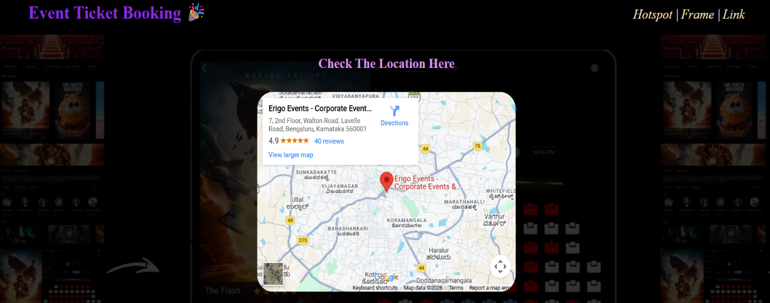
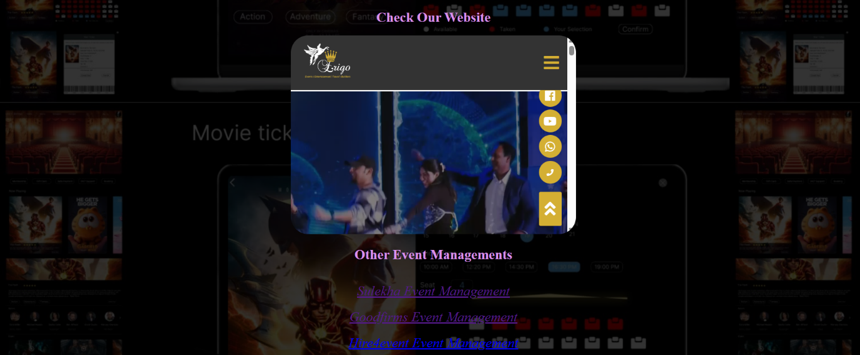

Result:
Html Page is created with embedded Bangalore map along with hot spot, frames ,map & Links.

